Part I: Multiple Choice (no calculator)

|  |
| --- |
| 1) If *y* = *x* sin *x*, then *dy/dx* =  A) sin *x* + cos *x*  B) sin *x* + *x*cos *x*  C) sin *x* – *x*cos *x*  D) *x*(sin *x* + cos *x*)  E) *x*(sin *x* – cos *x*) |
| 2) If *f* (*x*) = 7*x* – 3 + ln *x*, then $f^{'}\left(1\right)=$ A) 4  B) 5  C) 6  D) 7  E) 8 |
| 3) The graph of function *f* is shown. Which of the following statements is false?  (E) The function *f* is continuous at *x* = 3. |
| 4) If *y* = (*x*3 – cos *x*)5, then *y*’ = |
| 5) $f\left(x\right)=\left\{\begin{aligned}\frac{(2x+1)(x-2)}{x-2} for x≠2 \\ k for x=2\end{aligned}\right.$ Let *f* be the function defined above. For what value of *k* is *f* continuous at *x* = 2?  A) 0  B) 1  C) 2  D) 3  E) 5 |
| 6) If $f\left(x\right)=\sqrt{x^{2}-4} and g\left(x\right)=3x-2,$ then the derivative of *f* (*g* (*x*)) at *x* = 3 is |
| 7) |
| 8) The function *f* is defined by $f\left(x\right)=\frac{x}{x+2}$. What points (*x*, *y*) on the graph of *f* have the property that the line tangent to *f* at (*x*, *y*) has slope of $\frac{1}{2}$? |
| 9) The line *y* = 5 is a horizontal asymptote to the graph of which of the following functions? |
| 10) If  then is equal to  (A)  (B)  (C)  (D)  (E) |
| 11) If $\left(x+2y\right)∙\frac{dy}{dx}=2x-y, what is the value of \frac{d^{2}y}{dx^{2}} at the point \left(3, 0\right)?$ |
| 12)  (A)  (B)  (C)  (D)  (E)  13) If , then =  (A)  (B)  (C)  (D)  (E) |
| **Part II: Graphing Calculator is Allowed** |
| 14) Let *f* be a function that is continuous on the closed interval [2, 4] with *f* (2) = 10 and *f* (4) = 20. Which of the following is guaranteed by the Intermediate Value Theorem?  A) *f* (*x*) = 13 has at least one solution in the open interval (2, 4).  B) *f* (3) = 15  C) *f* attains a maximum on the open interval (2, 4).  D) *f* ‘(*x*) = 5 has at least one solution in the open interval (2, 4)  E) *f* ‘(*x*) > 0 for all *x* in the open interval (2, 4). |
| 15) |
| 16) A particle moves along the *x*-axis so that its position at any time t (in seconds) is . The acceleration of the object at *t* = 2 seconds is  (A) 19  (B) 11  (C) 16  (D) 4  (E) 0 |

Free Response: Part I: No Calculator

17) (1981 AB) Let f be defined by 

* 1. For what value(s) of *k* will *f* be continuous at *x* = 2? Justify with the definition.
  2. Find the average rate of change of the function on the interval [1, 4].
  3. Find the instantaneous rate of change of the function at *x* = 4.

18. Let  be the function defined by the equation .

1. Find the equations of the lines tangent and normal to the graph at the point .
2. Find the equation(s) of the line(s) tangent to the graph of  and parallel to the line .
3. At what value of x, if any, is the tangent line horizontal?

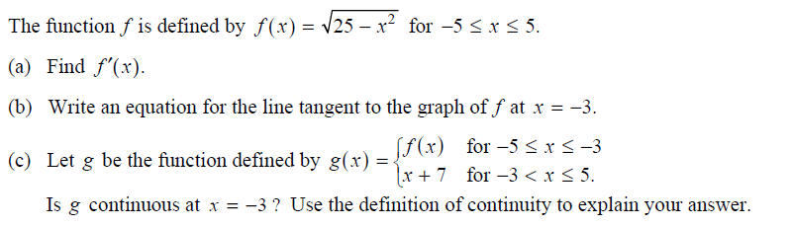

19.